Name
Class
Class no.
Date
Marks | / 50
Carmel Holy Word Secondary School
2024-2025 Term 2
Secondary 3 Computer Literacy
Practical Exam
Time: 45 Minutes

- Write your Name, Class and Class Number in the boxes provided.
- Follow the instructions below to finish the examination tasks.
- If you fail to upload your work, NO MARK will be given.

- ALL TASKS should be finished in VS Code.
- Login to Teams and open a folder named “S3 Term 2 Practical Exam”.
- Download the files “task2_2425.py”, “task3_2425.py” and “task4_2425.py” to your computer.
- Submit your work to the suitable assignments in Teams.

Task 1 (10 marks)
Write a program to produce the output shown in Figure 1 & 2 for Task 1.
(a) Create a Python file in VS Code and name it “task1_2425.py”.
- Ask the user to input an integer.
- Convert the input integer from string type to integer type.
- Create an if condition.
  - Check whether the input integer is even or odd.
  - If the number is even, print the number and claim it is even (As Figure 1 has shown).
  - If the number is odd, print the number and claim it is odd (As Figure 2 has shown).
- Save the file as “task1_2425.py” and submit it to Teams.

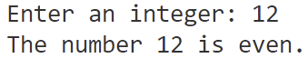

Figure 1

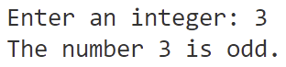

Figure 2

Task 2 (10 marks)
Write a program to produce the output shown in Figure 3 - 7 for Task 2.
(a) Download “task2_2425.py” from Teams and open it in VS Code.
(b) Create an empty list to store the input name.
(c) Add user’s input name into the name list.
(d) Remove user’s input name from the name list.
(e) Insert user’s input name to the name list’s first place.
(f) Complete an if condition.
- If the names inside the name list have more than five letters, add to long_names list.
(g) Save the file as “task2_2425.py” and submit it to Teams

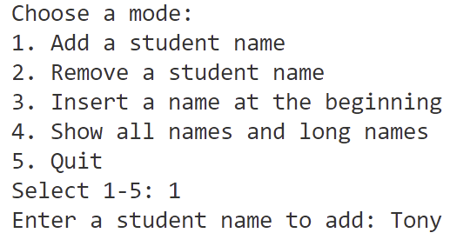

Figure 3

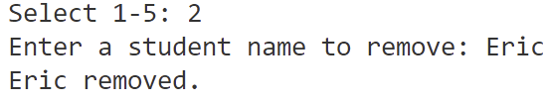

Figure 4

Figure 5

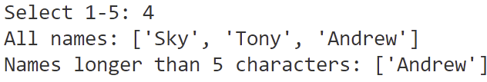

Figure 6

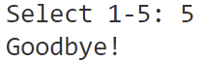

Figure 7

Task 3 (15 marks)
Write a program to convert a text to an audio.
(a) Download “task3_2425.py” from Teams and open it in VS Code.
(b) Import the library.
- Line 2: Text-To-Speech library.
- Line 3: Playsound library.
- Line 4: Operating system library.
(c) Main: Text-To-Speech, play the audio and delete the audio file.
- Line 9: Using Text-To-Speech library function to generate an audio of the text.
- Line 10: Using Text-To-Speech library function to save the audio as mp3 file in the same folder.
- Line 11: Using playsound library function to play the mp3.
- Line 12: Using os library function to delete the mp3 file.
(d) Save the file as “task3_2425.py” and submit it to Teams.

Task 4 (15 marks)
Write a program to detect faces in a video.
(a) Download “task4_2425.py” from Teams and open it in VS Code.
(b) Import the OpenCV library.
(c) Add a face detection model.
(d) Open the video file “video.mp4”.
(e) Loading a video
- Line 12: Read one frame from the video.
- Line 13 - 14: If the video was not playing, stop video.
(f) Show the video.
(g) Wait 1ms to close a frame.
(h) Save the file as “task4_2425.py” and submit it to Teams.

End of Paper

Appendix: Modules and Functions API Reference Table
Module Name | pip install | Example of Import Statement
gTTS | gTTS | from gtts import gTTS
Playsound | playsound==1.2.2 | from playsound import playsound
OS | / | import os
Speech Recognition | SpeechRecognition | import speech_recognition as sr
OpenCV | opencv-contrib-python | import cv2

Module | Description | Function Example
gTTS | Setup gTTS | audio = gTTS(text="I Love You", lang="en")
gTTS | Save TTS audio to a file | audio.save("audio.mp3")
Playsound | Play the audio file | playsound("audio.mp3")
OS | Delete a file in the folder | os.remove("output.mp3")
Speech Recognition | Create a Recognizer instance | recognizer = sr.Recognizer()
Speech Recognition | Initialize microphone input | mic = sr.Microphone()
Speech Recognition | Calibrate for ambient noise | recognizer.adjust_for_ambient_noise(source)
Speech Recognition | Listen and capture audio input | audio = recognizer.listen(source)
Speech Recognition | Convert audio to text using Google | text = recognizer.recognize_google(audio, language="en")
OpenCV | Read an image file | image = cv2.imread("face.jpg")
OpenCV | Open a video file or camera stream | cap = cv2.VideoCapture("video.mp4")
OpenCV | Read a frame from the video | isTrue, frame = cap.read()
OpenCV | Display the video frame in a window | cv2.imshow('Video', frame)
OpenCV | Wait for a key event (with delay) | cv2.waitKey(1)
OpenCV | Load a face detection model | face_cascade= cv2.CascadeClassifier("haarcascade_frontalface_default.xml")

